Terrorism

Instructor: Mark Bray Class Location: CA A3
E-mail: mark.bray@rutgers.edu Class Times: M/W 2:00-3:20

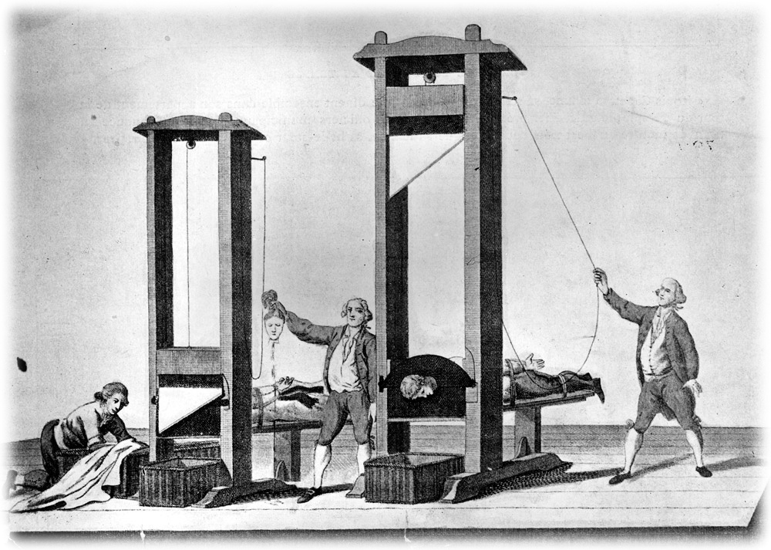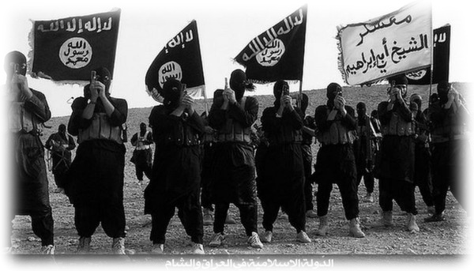
Politicians and commentators seem to agree that the specter of terrorism haunts the globe. From The Taliban to Al-Qaeda, from Boko Haram to ISIS, the “war against terror” has gripped 21st century global politics. Yet, it is often unclear exactly what distinguishes “terrorism” from other forms of political violence. Is it subjective? Is “one man’s terrorist another man’s freedom fighter”? Or can we clearly define consistent standards for violent political conduct? Is “terrorism” simply a label for non-state political violence or does it make sense to speak of “state terrorism”?

This 200-level course delves into the history and theory of terrorism from an interdisciplinary perspective in search of answers to these vexing questions. Through exploring perspectives form the fields of political science, religious studies, sociology, media studies, and history, this course travels from the guillotines of la Terreur during the French Revolution to the beheadings of ISIS to explore how the confluence of mass communications, technological developments such as the invention of dynamite, modern religious and secular ideological developments, and other factors have birthed a uniquely modern variant of political violence around the world.
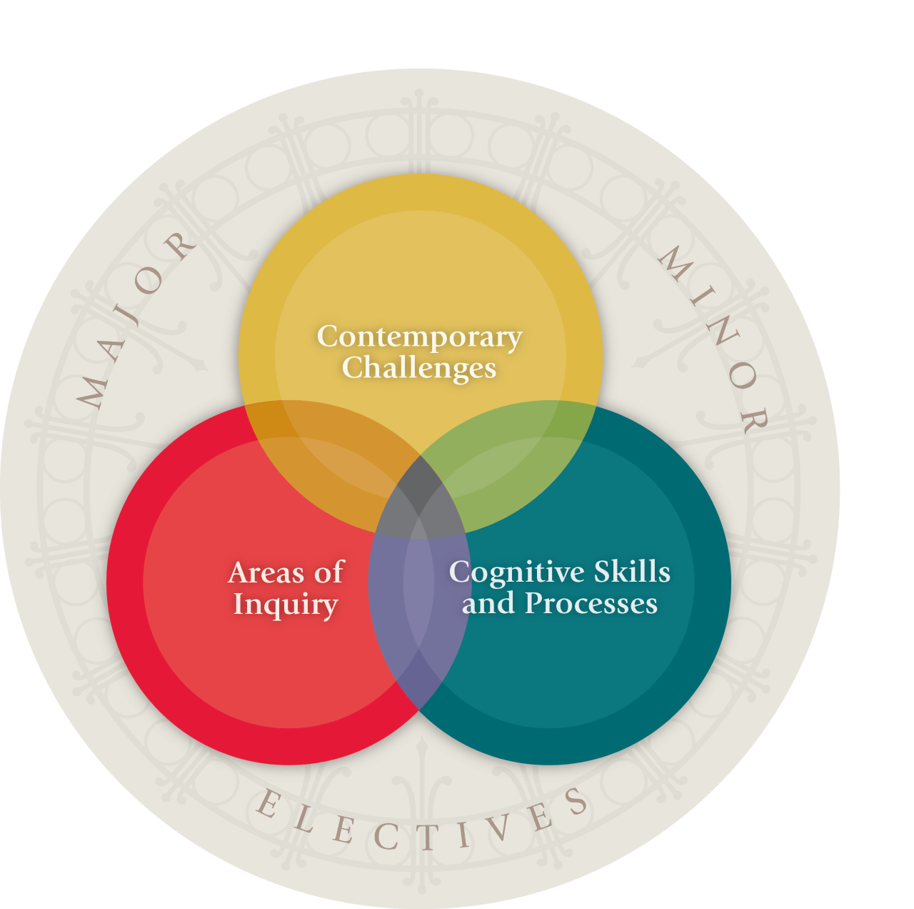
This course meets the SAS Core Learning Goal for Historical Analysis [HST]:
You will learn how to: employ historical reasoning to study human endeavors, using appropriate assumptions, methods, evidence, and arguments.

This course meets the SAS Core Learning Goal for Contemporary Challenges [CC]: You will analyze a contemporary global issue from a multidisciplinary perspective.

Learning Goals:

- Explain the basic origins and causes of terrorism.
- Assess the arguments for and against the use of the term “terrorism.”
- Analyze primary and secondary sources from the study of terrorism and political violence.
- Integrate various terrorist attacks and organizations into a broader interdisciplinary analysis of the phenomenon.

Readings
All readings will be available on Canvas or through links provided in the syllabus.

Assignments
The midterm essay will be due on Oct 23 by the start of class. You will write 4-6 pages, double-spaced, with 1” margins, and 12 pt. Times New Roman font.

For the documentary paper due Nov. 11 at the start of class, you will watch “Documenting Hate: New American Nazis” from PBS’ Frontline (https://youtu.be/-XFBVAAzXjc?si=YyHgGpvbewnWKECO) and then write 2-3 pages analyzing the documentary in light of class topics. It should be double-spaced, with 1” margins, and 12 pt. Times New Roman font.

You will write a short 2-3-page news article paper on a news article somehow related to terrorism as it pertains to the themes of the course. You will pick the article from a reputable news source. It is due Nov. 18 at the start of class. It should be double-spaced, have 1” margins, and 12 pt. Times New Roman font.

The Final Essay will be 7-9 pages, double-spaced, have 1” margins, and 12 pt. Times New Roman font. It is due Dec. 18 at 11:59 PM.

Academic Integrity
Rutgers defines academic integrity as the pursuit of scholarly activity in an open, honest and responsible manner. All students should act with personal integrity, respect other students’ dignity, rights and property, and help create and maintain an environment in which all can succeed to the best of their ability and effort.

Dishonesty of any kind will not be tolerated in this course. Dishonesty includes, but is not limited to, cheating, plagiarizing, fabricating information or citations, facilitating acts of academic dishonesty by others, having unauthorized possession of examinations, submitting work of another person or work previously used without informing the instructor, or tampering with the academic work of other students. Students found to be dishonest will suffer academic sanctions and will be reported to the University for possible further disciplinary sanction. Plagiarism is the most important issue of integrity in a research course. Do not engage in it in any form. If you have any questions about this, see me immediately.

Academic Accommodations
Rutgers University welcomes students with disabilities into all of the University's educational programs. In order to receive consideration for reasonable accommodations, a student with a disability must contact the appropriate disability services office at the campus where you are officially enrolled, participate in an intake interview, and provide documentation: https://ods.rutgers.edu/students/documentation-guidelines.

If the documentation supports your request for reasonable accommodations, your campus’s disability services office will provide you with a Letter of Accommodations. Please share this letter with your instructors and discuss the accommodations with them as early in your courses as possible. To begin this process, please complete the Registration form on the ODS web site at: https://ods.rutgers.edu/students/registration-form.

Attendance Policy
Attendance is mandatory and will be taken at the beginning of every class session. Over the course of the semester, you are allowed up to three absences, for any reason, without penalty. There is no need to email me to explain the absence. Any absences beyond three will harm your class participation grade. Absences due to routine schedule conflicts (job interviews, exams in other classes, etc.) or minor illnesses will not result in additional excused absences beyond the three already allotted. It is your responsibility to use your allotted absences responsibly over the course of the semester. Exception to this policy will be made for religious holidays, and for serious illnesses and family emergencies, by getting in touch with the Dean of Students.
Class participation will be assessed according to the following rubric:
A (13.5-15) | Student participated meaningfully in every, or nearly every, class discussion; offered comments and/or questions that reflected substantive engagement with the assigned reading; and responded thoughtfully to the other students’ and professor’s own contributions to class discussions
B  (12-13.4) | Student excelled in most of the above ways, but fell somewhat short on one or two of the criteria (e.g., had more than a few days of no oral participation, or about a third of the time made comments that reflected only a superficial engagement with the assigned reading)
C  (10.5-11.9) | Either the student excelled in some criteria but failed in others (e.g., made frequent contributions in class but comments were not relevant to the topic or did not reflect engagement with the assigned reading), or the student performed merely adequately on all the above criteria (e.g., only sometimes participated in class discussions)
D (9-10.4) | Student did not meet most of the above criteria overall, but occasionally did meet one of the above criteria.
F | Student did not engage with the lecture material, assigned reading, or class discussion throughout the semester.

Grading
Attendance/Participation: 15%
Midterm Essay: 25%
News Article Paper: 15%
Documentary Paper: 15%
Final Essay: 30%

Course Schedule:

Sept 4: What is “terrorism”?

Sept 9: La Terreur in the French Revolution
Reading: Maximilien Robespierre, “On the Moral and Political Principles of Domestic Policy”

Sept 11: Slavery
Reading: “The Dungeon on the Hacienda La Cuba”

Sept 16: Colonialism and Imperialism

Sept 18: Anarchist “propaganda by the deed”
Reading: Paul Brousse “Propaganda by the Deed” and Carlo Cafiero “Action” in Robert Graham ed., Anarchism: A Documentary History of Libertarian Ideas, and Émile Henry, “Letter to the Director of the Conciergerie” (https://www.marxists.org/reference/archive/henry/1894/conciergerie.htm)

Sept 23: Karakazov and the assassination of Tsar Alexander II in Russia
Reading: Sergei Nechaev, “The Revolutionary Catechism” (https://www.marxists.org/subject/anarchism/nechayev/catechism.htm)

Sept 25: Colonialism and Anti-Colonialism in Ireland (Part 1)

Sept 30: “Red Terror,” Lenin, and Stalin
Reading: Lenin “The Dictatorship of the Proletariat”

Oct 2: Colonialism and Anti-Colonialism in Palestine (Part 1)

Oct 7: Colonialism and Anti-Colonialism in Palestine (Part 2)

Oct 9: KKK and Jim Crow

Oct 14: Fascism and Nazism in Interwar Europe
Reading: A. James Gregor, “Fascism’s Philosophy of Violence and the Concept of Terror,”

Oct 16: Frantz Fanon
Reading: Wretched of the Earth, “Concerning Violence”

Oct 21: Colonialism and Anti-Colonialism in Algeria
Watch: The Battle of Algiers

Oct 23: Colonialism and Anti-Colonialism in India
***Midterm Essay Due at the start of class***

Oct 28: Car bombs
Reading: Mike Davis, Buda’s Wagon

Oct 30: The Weather Underground
Watch: “The Weather Underground”

Nov 4: The Far Right in the United States after Civil Rights Legislation

Nov 6: Colonialism and Anti-Colonialism in Ireland (Part 2)
Reading: Diary of Bobby Sands: (https://www.pbs.org/wgbh/pages/frontline/shows/ira/readings/diary.html)

Nov 11: Apartheid and anti-Apartheid in South Africa
***Documentary paper due at start of class***

Nov 13: Dirty Wars in Latin America
Reading: tbd

Nov 18: Police and Prisons
***News article paper due!!***

Nov 20: Al-Qaeda
Reading: Robert A. Pape, “The strategic logic of suicide terrorism.”

Nov 25: Counter-terrorism and the “War on Terror”
Reading: “Torture at Abu Ghraib”

Dec 2: ISIS

Dec 4: The PKK and Kurdish National Liberation
Reading: Interview with Ocalan:
https://www.meforum.org/399/abdullah-ocalan-we-are-fighting-turks-everywhere

Dec 9: Boko Haram
Reading: Interview: Life After Escaping Boko Haram’s Clutches (https://www.hrw.org/news/2014/10/27/interview-life-after-escaping-boko-harams-clutches)

Dec 11: “Cyber-terrorism”

***Final Paper due December 18 at 11:59 PM***

